

HTML Project

Big Data



2018-2019-3

University Of Petra

**Team Members:**

* Bahaaldin Hmiedan: 201910443 CS
* Mohammad Sameer: 201911238 CS

**Course:** Computer Skills – Tech 9600102

**Instructor:** Ms. Tharife Al-Khuffash

**Section:**

# Logo:



# Color Theme

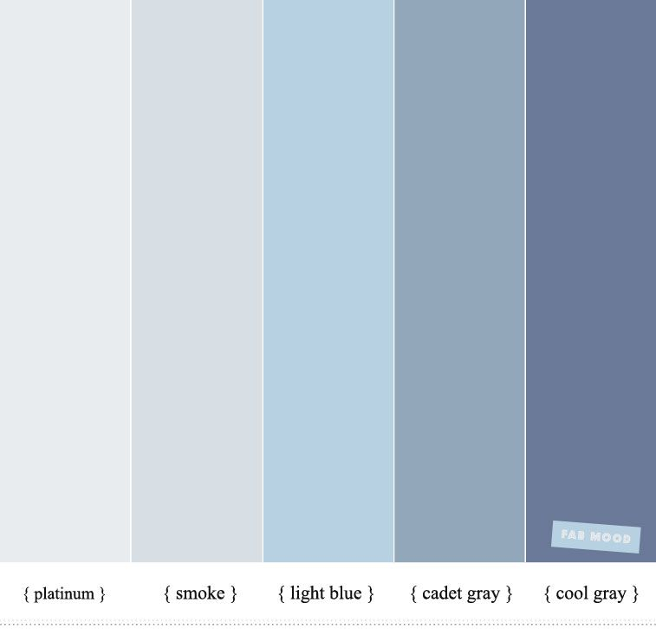

# Pages Structure:

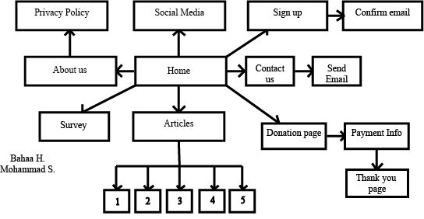

**Pages to do**

* Home Page: Navigation bar, Introduction to Website, Footer, Image and Logo
* About us: Information about website, goals

&Privacy Policy Page

* Contact us: Link to send email, Telephone, User help, contact image
* Sign up: User info name, age, email, gender etc…
  + Confirmation page to verify email
* Social Media: Links to Facebook, Instagram, Snapchat (Use UOP snapchat code image) twitter
* Survey: Questions about user satisfaction and user feedback.
* Donation Page: Explaining the importance of donations(paragraph) Images.
* Payment page: User Credit card info or paypal, Email and password

&Thank you message if user donates.

* Articles: Descriptions and articles about Big data and the future of big data. (5 Pages total) Pages include links to donation page.
* Article 1:
* Article 2:
* Article 3:
* Article 4:
* Article 5:

18-20 pages total

# Follow Up:

Attendance:

Notes:

# Final Presentation

Attendance:

Notes:

*Project*

*Individual*

------------------------------------------------------------------------------------------------------------------------------------------------------------------------------------------------------------------------------------------------------------------------------------------------------------------------------------------------------------------------------------------------------------------------------------------------------------------------------------------------------------------------------------------------------------------------------------------------------------------------------------------------------------------------------------------------------------------------------------------------------------------------------------------------------------------------------------------------------------------------------------------------------------------------------------------------------------------------------------------------